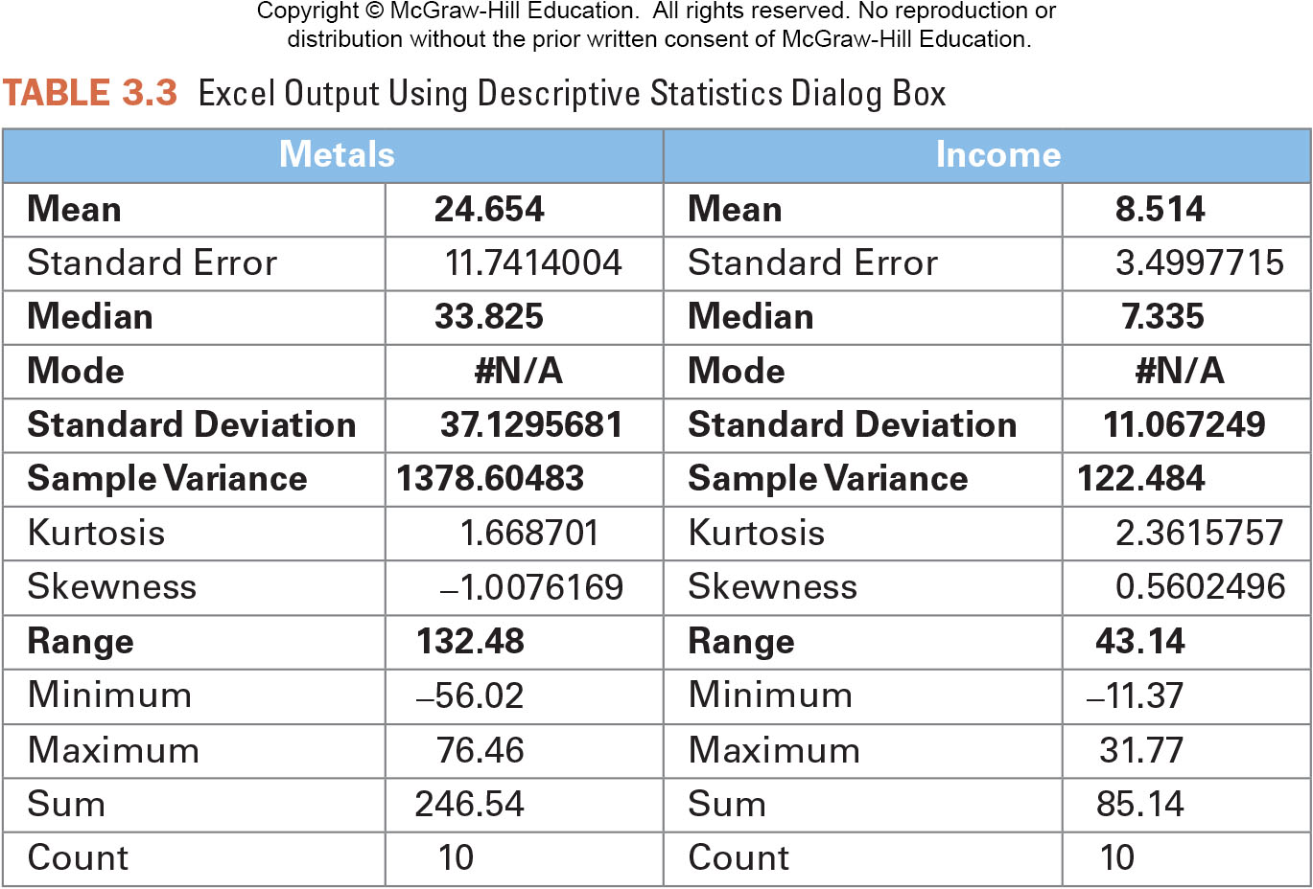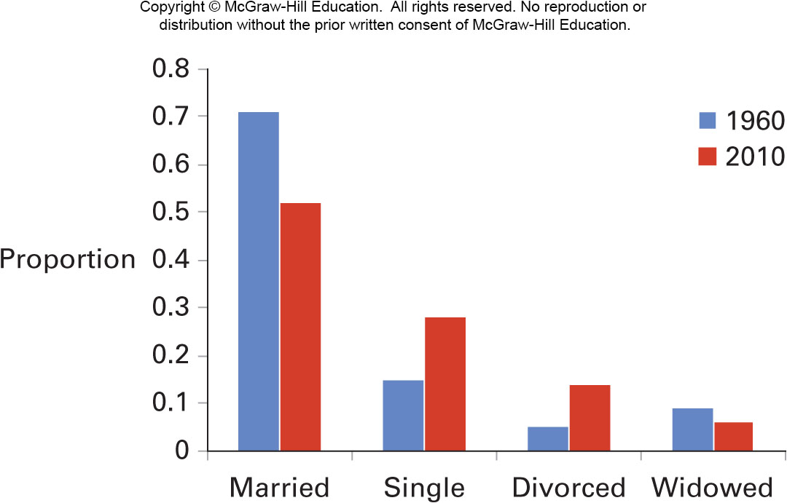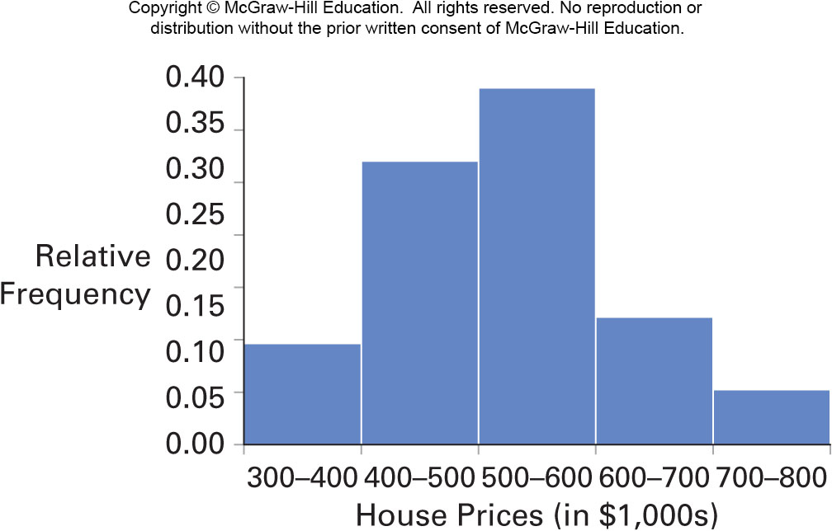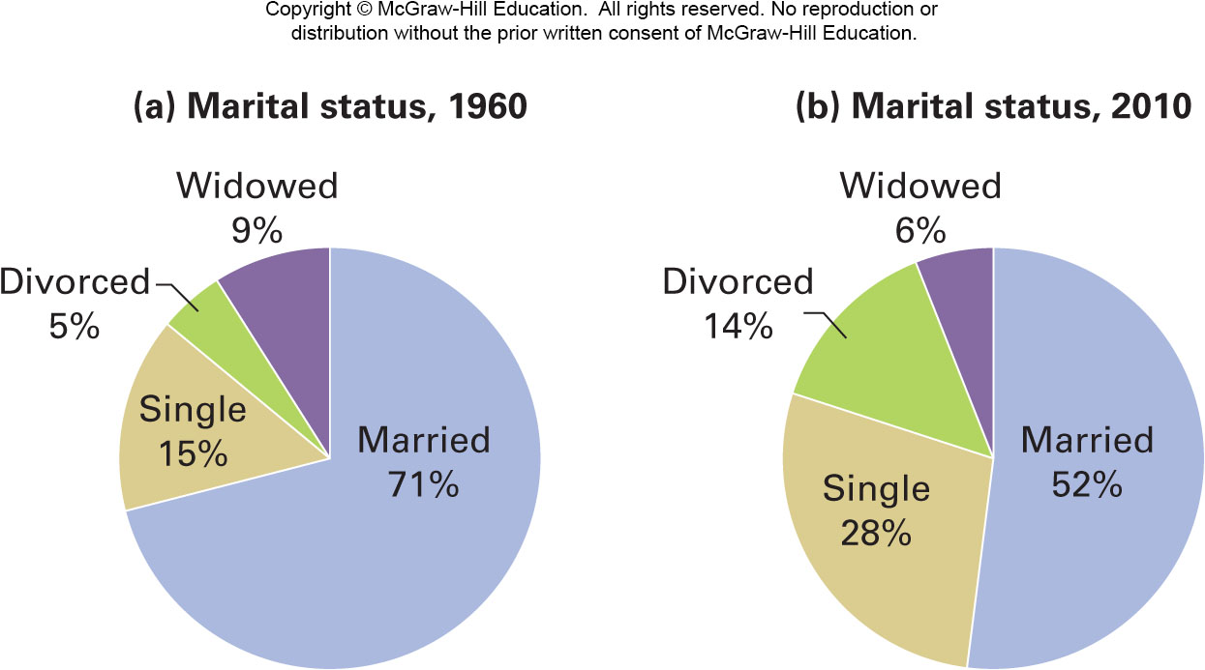

Sampling – take a representative subset of American HS teachers

Sample

$\overline{x}$ (sample statistics)

$\overline{x}$ = Average salary of the sample

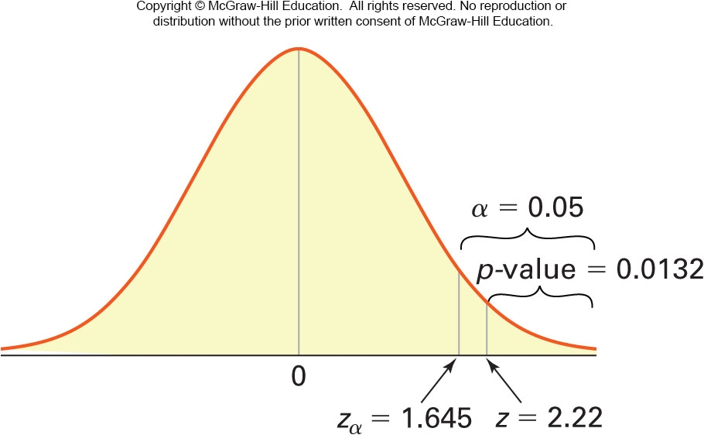

Inferential Statistics – Estimate parameters and text hypotheses about parameters

Descriptive Statistics – numerical and graphical summaries of data

\*Cost prohibitive or \*infeasible to study the entire population

Population

Example: American HS Teachers

$μ, σ, χ, p$ (population parameters)

$μ$ =Average salary of American HS teachers